**Project 3**

**Project Report – Chord Simulator**

**Ammar Amjad 5992-1730, Mohammad Anas 5981-5998**

**October 23rd, 2022**

**Task:**

To implement a simulation of the Chord Peer to Peer system and determine the convergence hops for message to traverse to destination.

**What is Working?**

Correct creation of chord with desired number of nodes and then calcualation of the average hops required for a given number of requests where each node maintains a finger table consisting of logN nodes.

**Steps for exection are given below:**

- Run the project by using commands in terminal:

-> c(project3).

-> project3:runApp( NumNodes, NumRequests).

where NumNodes = number of nodes, NumRequests = number of requests to be sent.

**What is the largest network you managed to deal with for Chord algorithm?**

For Request count = 1000 , The largest chord with nodes = 1000, took hops = 13

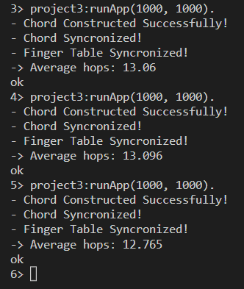

**Largest number of Requests:**

For Request count = 1000000 , and with nodes = 10, hops taken = 1

Largest Number of Nodes:  
For Request count = 10 , and with nodes = 1000000, hops taken = 1